**Topic 1: IT in Automobiles**

**COLLEGE NAME – Lamrin tech skills university Punjab  
BRANCH- Btech (Electrical Engineering )  
PRESENTED BY – Sudhir Bhardwaj ( 24100130006 )  
ROLL**

**Presentation Points**:

1. **Introduction**:
   * IT in automobiles has revolutionized the way we travel.
   * Modern cars are not just vehicles; they are smart machines.
2. **Key Areas of IT Integration**:
   * **Navigation Systems**: GPS, live traffic updates, and route planning.
   * **Safety Features**: Sensors, cameras, and Automatic Emergency Braking (AEB).
   * **Connected Cars**: Internet-enabled vehicles for better communication.
   * **Electric and Autonomous Vehicles**: Software for self-driving and energy management.
3. **Benefits**:
   * Improved safety, efficiency, and user convenience.
   * Reduced environmental impact with electric vehicles.
4. **Future Scope**:
   * Enhanced AI for self-driving.
   * Vehicle-to-Everything (V2X) communication.
5. **Extempore Speech**:  
   "Today, IT has transformed automobiles into intelligent systems. Features like GPS navigation, automated braking, and connectivity make our journeys safer and smarter. The rise of electric and self-driving cars shows the future of IT-driven innovation in this field."

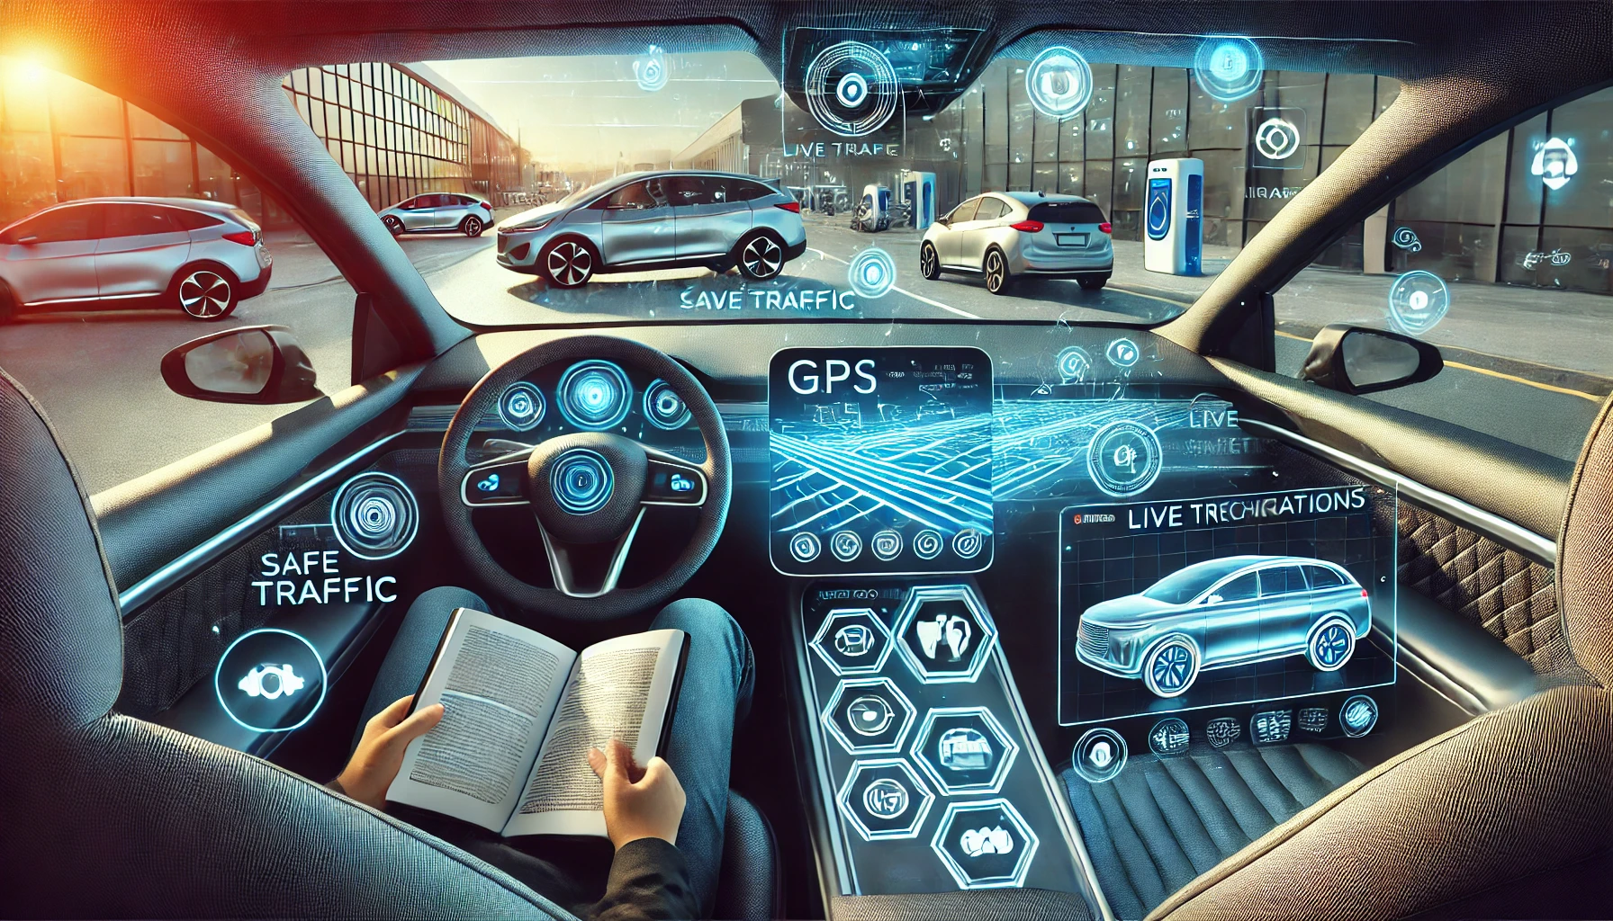

**Topic 2: IT in Metro Rail**

**Presentation Points**:

1. **Introduction**:
   * IT is the backbone of modern metro rail systems.
   * Ensures safe, efficient, and smooth operations.
2. **Applications of IT**:
   * **Ticketing Systems**: Smart cards, QR codes, and mobile apps.
   * **Automation**: Driverless trains and automated signaling.
   * **Passenger Information Systems**: Real-time updates on train timings.
   * **Operations Management**: Monitoring trains and power systems remotely.
3. **Benefits**:
   * Reduces human error and increases safety.
   * Enhances commuter experience.
4. **Future Trends**:
   * AI for predictive maintenance.
   * IoT for integrated transport systems.

**Extempore Speech**:  
"IT has made metro rail systems highly efficient and commuter-friendly. From automated ticketing to driverless trains, technology ensures safety and convenience. The integration of AI and IoT is set to make metro systems even smarter."

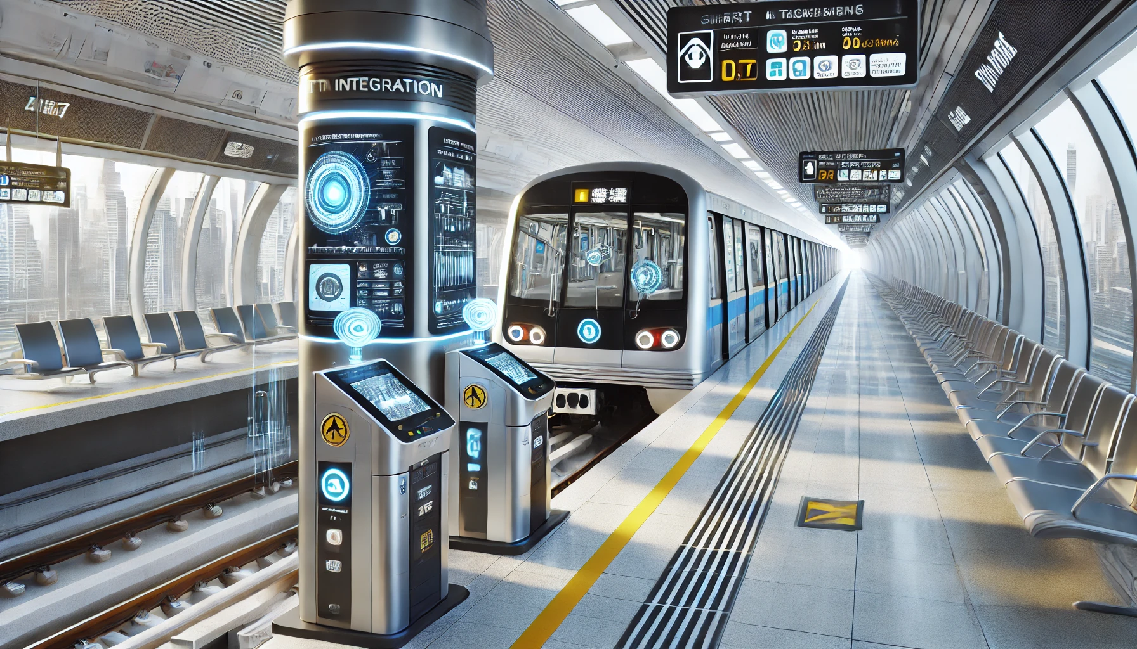

**Topic 3: IT in Avionics**

**Presentation Points**:

1. **Introduction**:
   * IT plays a crucial role in avionics, enhancing safety and performance.
   * Avionics refers to the electronic systems used in aircraft.
2. **Key IT Contributions**:
   * **Navigation and Communication**: GPS and real-time data sharing.
   * **Flight Control Systems**: Automated controls for smoother operations.
   * **Passenger Experience**: In-flight entertainment and Wi-Fi connectivity.
   * **Maintenance Systems**: Predictive maintenance using data analytics.
3. **Benefits**:
   * Enhances safety and operational efficiency.
   * Provides better experiences for passengers.
4. **Future Developments**:
   * AI-driven autopilot systems.
   * Use of AR/VR for pilot training.

**Extempore Speech**:  
"IT is the heart of modern avionics, ensuring safe and efficient flights. From advanced navigation systems to in-flight entertainment, it enhances both operations and passenger experience. The future holds exciting possibilities with AI and VR technologies."

